Regie Pineda

Dr. Ahmed Awad

CSS 422

November 22nd, 2019

Homework 4

Q1. Consider the logic gate circuit shown below

1. (2 points) Derive a Boolean equation for the output X
$$\overline{\overline{(\left(A⊕C\right)}+\overline{B})} \overline{(\overline{B}(B+D))}$$

2. (3 points) Draw a truth table for the circuit

|  |  |  |  |  |  |
| --- | --- | --- | --- | --- | --- |
| # | A | B | C | D | X |
| 0 | 0 | 0 | 0 | 0 | 0 |
| 1 | 0 | 0 | 0 | 1 | 0 |
| 2 | 0 | 0 | 1 | 0 | 0 |
| 3 | 0 | 0 | 1 | 1 | 0 |
| 4 | 0 | 1 | 0 | 0 | 0 |
| 5 | 0 | 1 | 0 | 1 | 0 |
| 6 | 0 | 1 | 1 | 0 | **1** |
| 7 | 0 | 1 | 1 | 1 | **1** |
| 8 | 1 | 0 | 0 | 0 | 0 |
| 9 | 1 | 0 | 0 | 1 | 0 |
| A | 1 | 0 | 1 | 0 | 0 |
| B | 1 | 0 | 1 | 1 | 0 |
| C | 1 | 1 | 0 | 0 | **1** |
| D | 1 | 1 | 0 | 1 | **1** |
| E | 1 | 1 | 1 | 0 | 0 |
| F | 1 | 1 | 1 | 1 | 0 |

Q2. Introduction to Logisim

This question will introduce you to Logisim – a graphical tool for designing and simulating logic circuit/system

**Note:** I followed the steps to obtain the circuit file. After finishing all the steps, I then save the circuit file and submitted separately.

Q3.  Virtual memory and cache

Design a combinational circuit with three inputs x,y,z, and three outputs A,B,C. When the binary inputs is 0,1,2, or 3, the binary output is two greater than the input. When the binary input is 4,5,6, or 7, the binary output is one less than the input.

Please answer all of the following sub-questions.

1. (3 points) x,y,z are inputs and A,B,C are outputs. Draw a truth table for the given function.

|  |  |  |  |  |  |
| --- | --- | --- | --- | --- | --- |
| X | Y | Z | A | B | C |
| 0 | 0 | 0 | 0 | 1 | 0 |
| 0 | 0 | 1 | 0 | 1 | 1 |
| 0 | 1 | 0 | 1 | 0 | 0 |
| 0 | 1 | 1 | 1 | 0 | 1 |
| 1 | 0 | 0 | 0 | 1 | 1 |
| 1 | 0 | 1 | 1 | 0 | 0 |
| 1 | 1 | 0 | 1 | 0 | 1 |
| 1 | 1 | 1 | 1 | 1 | 0 |

1. (3 points) Based on the truth table you draw, build Karnaugh maps for the output A, B, C.

|  |  |  |  |  |
| --- | --- | --- | --- | --- |
| Table A | $$\overline{x}\overline{y}$$ | $$\overline{x}y$$ | $$xy$$ | $$x\overline{y}$$ |
| $$\overline{z}$$ |  | 1 | 1 |  |
| $$z$$ |  | 1 | 1 | 1 |

|  |  |  |  |  |
| --- | --- | --- | --- | --- |
| Table B | $$\overline{x}\overline{y}$$ | $$\overline{x}y$$ | $$xy$$ | $$x\overline{y}$$ |
| $$\overline{z}$$ | 1 |  |  | 1 |
| $$z$$ | 1 |  | 1 |  |

|  |  |  |  |  |
| --- | --- | --- | --- | --- |
| Table C | $$\overline{x}\overline{y}$$ | $$\overline{x}y$$ | $$xy$$ | $$x\overline{y}$$ |
| $$\overline{z}$$ |  |  | 1 | 1 |
| $$z$$ | 1 | 1 |  |  |

1. (3 points) Derive (as simple as possible) Boolean equations for A,B,C using the Karnaugh maps

A = Y + XZ

B = ~X~Y+XYZ+~Y~Z

C = X~Z+~XZ

(3 points) Based on the Boolean equations, draw the logical gate diagram (circuit) for this system in Logisim. **Save the circuit file and submit it as an individual file!**



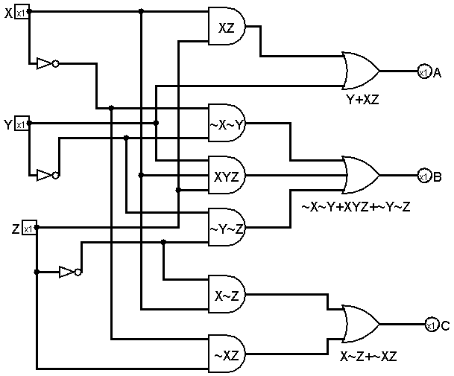

1. (2 points) Test your circuit with the Logisim simulation and generate the truth table (In logisim, project-->analyze circuit-->table). **Copy & past the table in your submission!**

